**Topics: Normal distribution, Functions of Random Variables**

1. The time required for servicing transmissions is normally distributed with *μ* = 45 minutes and *σ* = 8 minutes. The service manager plans to have work begin on the transmission of a customer’s car 10 minutes after the car is dropped off and the customer is told that the car will be ready within 1 hour from drop-off. What is the probability that the service manager cannot meet his commitment?
2. 0.3875
3. 0.2676
4. 0.5
5. 0.6987

Solution: Option B. 0.2676

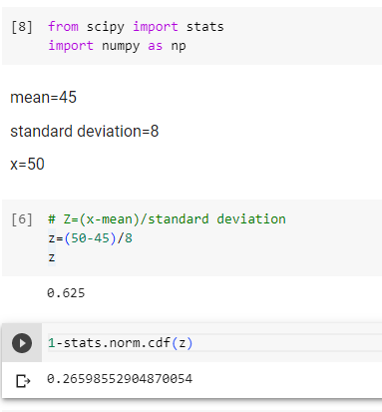

1. The current age (in years) of 400 clerical employees at an insurance claims processing center is normally distributed with mean *μ* = 38 and Standard deviation *σ* =6. For each statement below, please specify True/False. If false, briefly explain why.
2. More employees at the processing center are older than 44 than between 38 and 44.

False

1. A training program for employees under the age of 30 at the center would be expected to attract about 36 employees.

True

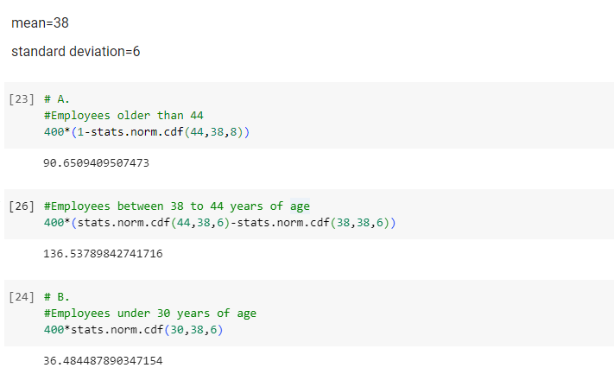

1. If *X1* ~ *N*(μ, σ2) and *X*2 ~ *N*(μ, σ2) are *iid* normal random variables, then what is the difference between 2 *X*1 and *X*1 + *X*2? Discuss both their distributions and parameters.

Solution:

If, X1~~ *N*(μ, σ2) is normally distributed then 2X1  is N(2μ,2 σ2) also distributed normally.

Similarly,If *X1* ~ *N*(μ, σ2) and *X*2 ~ *N*(μ, σ2) is normally distributed ,

*X*1 + *X*2 ~ *N*(μ + μ, σ2 + σ2 )= *N*(2μ,2 σ2)

Therefore 2X1 = *X*1 + *X*2 If the μ and σ2 of both the distributions are same

1. Let X ~ N(100, 202). Find two values, *a* and *b*, symmetric about the mean, such that the probability of the random variable taking a value between them is 0.99.
2. 90.5, 105.9
3. 80.2, 119.8
4. 22, 78
5. 48.5, 151.5
6. 90.1, 109.9

Solution:

Option D.48.5,151.5

The Probabilities of a and b, we need to calculate X, the random variable at a and b which has got these probabilities.

By finding the Standard Normal Variable Z (Z Value), we can calculate the X values.

Z=(X-μ) / σ, For Probability 0.005 the Z Value is -2.57 (from Z Table).

Z * σ + μ = X

Z(-0.005)*20+100 = -(-2.57)*20+100 = 151.4

Z(+0.005)*20+100 = (-2.57)*20+100 = 48.6

1. Consider a company that has two different divisions. The annual profits from the two divisions are independent and have distributions Profit1 ~ N(5, 32) and Profit2 ~ N(7, 42) respectively. Both the profits are in $ Million. Answer the following questions about the total profit of the company in Rupees. Assume that $1 = Rs. 45

Mean=5+7=$12

Mean in Rs.=12*45=Rs.540 million

Standard deviation=(9+16)1/2=5

Standard deviation in Rs=5*45=225 millions

1. Specify a Rupee range (centered on the mean) such that it contains 95% probability for the annual profit of the company.

Solution:By emperical rules, 95% of data lies 2 standard deviation apart from the mean.

Range(540-2*225,540+2*225)

Range(90,990)

1. Specify the 5th percentile of profit (in Rupees) for the company

Solution: Percentile=mean+z*standard deviation

Z score for 5th percentile ~-1.64

Percentile=540+(-1.64)*225

Percentile=540-369

Percentile=171

1. Which of the two divisions has a larger probability of making a loss in a given year?

Solution

Solution:DiDivision1 has a larger probability of making a loss

